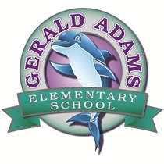

SAC Agenda 11/14/2018

8:30 am in the Media Center

1. Meeting Call to Order
2. Adoption of Agenda
3. Introduction & Welcome
4. New Business
5. Construction Presentation by Ajax Project Manager James Marini

⦁Construction update

⦁View renderings of new building

1. Discuss upcoming school/holiday events
2. Open Agenda
3. Next Meeting Confirmation / Adjournment

**Chairman Notes:**

* Upcoming SAC meeting dates: Next meeting will be scheduled once we are in new building.
* Discuss plans for Open House of new school

**At Gerald Adams Elementary, we are committed to working to collaboratively provide a quality learning environment in which ALL children can learn and develop to their maximum potential.**